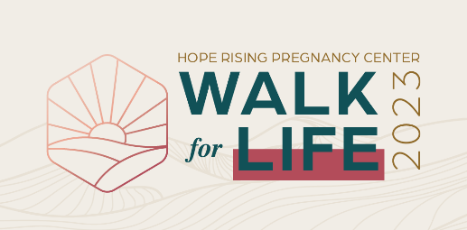
SAMPLE EMAILS/TEXTS
These can be cut and pasted into individual emails or texts to friends and family. It can also be used as “Your Welcome Message” on your FundEasy page.

INTRODUCTION for NEW sponsors
Suggested subject line: Will you help me raise funds to save unborn lives?
Dear ___________________________,
On April 29, I am participating as a Sponsored Walker for the Hope Rising Pregnancy Center Walk for Life. Hope Rising offers practical help and support for anyone facing an unplanned pregnancy. They provide all services and programs at NO cost. Since opening in 1982, Hope Rising has helped almost 16,000 women choose life for their babies. Their mission of protecting pre-born babies is critical: abortions are on the rise by at least 7% both locally and across Ohio (OH Dept. of Health, 2022).
My goal is (fill in), and I am participating because (fill in with your personal reason). Would you support me and this ministry by sponsoring me in the Walk for Life?

INTRODUCTION for PAST sponsors
Suggested subject line: Will you sponsor me again for this year’s Walk for Life?
Hi ,
The Hope Rising Pregnancy Center’s Walk for Life is just around the corner and once again I will be participating as a Sponsored Walker. This year’s Walk goal is $250,000 which will help fund the free, compassionate services they provide for anyone experiencing an unplanned pregnancy. The latest statistics show that abortions are on the rise by at least 7% both locally and across Ohio (OH Dept. of Health, 2022). Hope Rising’s work of protecting pre-born babies from abortion is critical – and since opening in 1982, they’ve served almost 16,000 clients who chose life!
My goal is (fill in), and I am participating because (fill in with your personal reason). Would you support me and this ministry by sponsoring me again?

REMAINDER of email for past AND new sponsors
Funds I raise directly support programs and services provided at NO COST to the client. To learn more, visit their website at supporthoperising.org. Please help me reach my goal by sponsoring me for $25, $50, $100 or whatever the Lord leads you to give. You can pay me ahead of time with cash or check (made out to Hope Rising).
Please reply to this e-mail (or let me know if you’ll sponsor me on FundEasy) with your complete address, sponsorship amount, and payment method. Gifts are tax deductible and receipts will be mailed for gifts of $25 or more, unless specifically requested.
If you are using FundEasy, share how they can sponsor you online:
You can also see how I am doing and sponsor me online. Go to supporthoperising.org, click on Walk for Life, then click the box that says Sponsor a Walker.
Thank you for helping save unborn lives and spread hope to our community!

