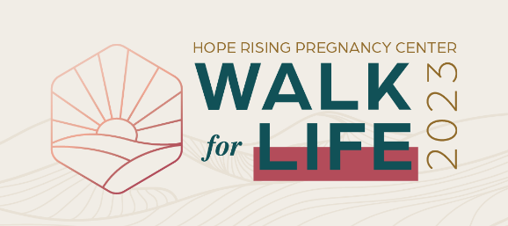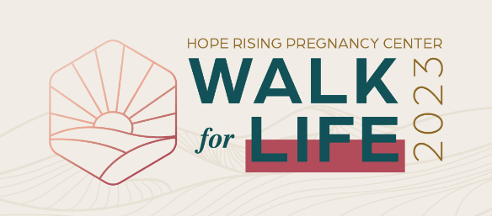

The number of abortions in Ohio increased by 7% from 2020 to 2021 – with 21,813 unborn lives terminated in 2021* – and despite the overturn of Roe v. Wade, abortion is once again legal in our state through 22 weeks. (*OH Department of Health, 2022)

Hope Rising (formerly Miami Valley Women’s Center) is working to protect pre-born babies by offering practical help and gospel hope to anyone experiencing an unplanned pregnancy.

**WILL YOU SUPPORT THE WALK FOR LIFE?**

Isaiah 30:18 says, “The Lord longs to be gracious to you; therefore, He will rise up to show you compassion…” Every dollar raised will help us demonstrate God’s grace by providing free, compassionate help to our clients.

* Go to **supporthoperising.org** for details and learn how to raise funds as a Sponsored Walker or sponsor a Walker.
* Pick a goal and earn prizes when you raise $100, $500, or $1,000!

$100 Earns a Walk for Life t-shirt

$500 Earns a t-shirt and Hope Rising tumbler

$1,000 Earns a t-shirt, tumbler, and invitation to the

Lifesaver Dinner on June 13

* Ask friends and family to sponsor you! Payment methods are cash, check (made out to Hope Rising), credit card (online), or we can send a bill for pledges of $25 or more.

**JOIN US APRIL 29 AT SOUTHBROOK CHRISTIAN CHURCH!**

Please consider supporting this major fundraiser for Hope Rising. May we as a church rise up to show compassion to the lost and hurting world around us.

For more details, visit **supporthoperising.org.**

The number of abortions in Ohio increased by 7% from 2020 to 2021 – with 21,813 unborn lives terminated in 2021* – and despite the overturn of Roe v. Wade, abortion is once again legal in our state through 22 weeks. (*OH Department of Health, 2022)

Hope Rising (formerly Miami Valley Women’s Center) is working to protect pre-born babies by offering practical help and gospel hope to anyone experiencing an unplanned pregnancy.

**WILL YOU SUPPORT THE WALK FOR LIFE?**

Isaiah 30:18 says, “The Lord longs to be gracious to you; therefore, He will rise up to show you compassion…” Every dollar raised will help us demonstrate God’s grace by providing free, compassionate help to our clients.

* Go to **supporthoperising.org** for details and learn how to raise funds as a Sponsored Walker or sponsor a Walker.
* Pick a goal and earn prizes when you raise $100, $500, or $1,000!

$100 Earns a Walk for Life t-shirt

$500 Earns a t-shirt and Hope Rising tumbler

$1,000 Earns a t-shirt, tumbler, and invitation to the

Lifesaver Dinner on June 13

* Ask friends and family to sponsor you! Payment methods are cash, check (made out to Hope Rising), credit card (online), or we can send a bill for pledges of $25 or more.

**JOIN US APRIL 29 AT SOUTHBROOK CHRISTIAN CHURCH!**

Please consider supporting this major fundraiser for Hope Rising. May we as a church rise up to show compassion to the lost and hurting world around us.

For more details, visit **supporthoperising.org.**