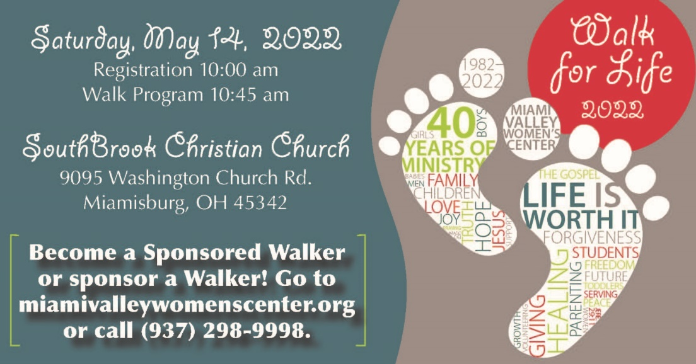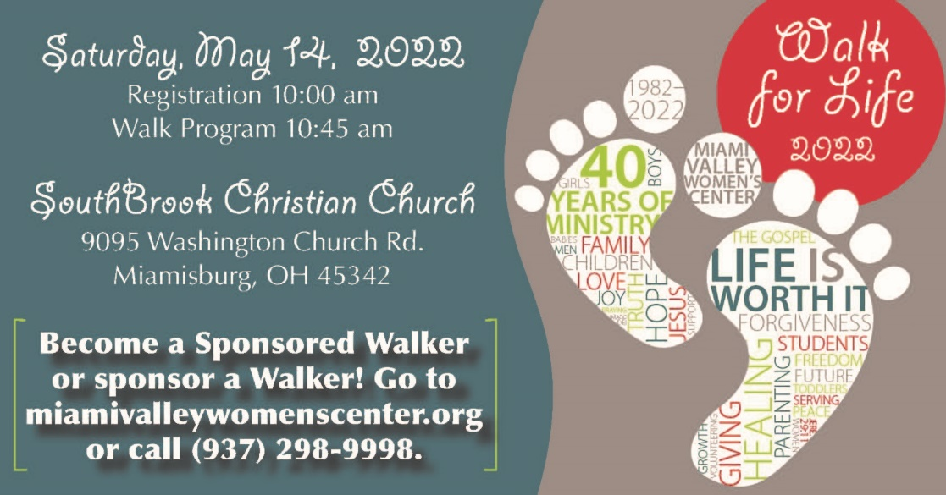

It’s critical for Christians to stand firm in the battle to protect unborn life. In 2020, almost 2,800 unborn babies were aborted in Montgomery County. Nationwide, 54% of abortions are induced through the abortion pill, which is approved by the FDA and readily available online.

God’s Word encourages us: *“Always give yourselves fully to the work of the Lord, because you know that your labor in the Lord is not in vain.”* Through the generosity of ministry partners, **over 15,000 women have chosen life** since Miami Valley Women’s Center opened 40 years ago!

**WILL YOU SUPPORT THE WALK FOR LIFE?**

Every dollar raised will help us provide free, compassionate help to our clients and share the hope of the gospel!

* Go to **miamivalleywomenscenter.org** for details and learn how to raise funds as a Sponsored Walker or sponsor a Walker.
* Pick a goal and earn prizes when you raise $300, $500, or $1,000!

$1,000 Provides 8 cribs

$500 Provides 5 car seats

$300 Provides 4 strollers

* Payment methods are cash, check (made out to MVWC), credit card (online), or we can send a bill for pledges of $25 or more.

**JOIN US MAY 14 AT SOUTHBROOK CHRISTIAN CHURCH!**

Please consider supporting this major fundraiser for the MVWC.

For more information, visit **miamivalleywomenscenter.org.**

**LIFE is worth it!**

It’s critical for Christians to stand firm in the battle to protect unborn life. In 2020, almost 2,800 unborn babies were aborted in Montgomery County. Nationwide, 54% of abortions are induced through the abortion pill, which is approved by the FDA and readily available online.

God’s Word encourages us: *“Always give yourselves fully to the work of the Lord, because you know that your labor in the Lord is not in vain.”* Through the generosity of ministry partners, **over 15,000 women have chosen life** since Miami Valley Women’s Center opened 40 years ago!

**WILL YOU SUPPORT THE WALK FOR LIFE?**

Every dollar raised will help us provide free, compassionate help to our clients and share the hope of the gospel!

* Go to **miamivalleywomenscenter.org** for details and learn how to raise funds as a Sponsored Walker or sponsor a Walker.
* Pick a goal and earn prizes when you raise $300, $500, or $1,000!

$1,000 Provides 8 cribs

$500 Provides 5 car seats

$300 Provides 4 strollers

* Payment methods are cash, check (made out to MVWC), credit card (online), or we can send a bill for pledges of $25 or more.

**JOIN US MAY 14 AT SOUTHBROOK CHRISTIAN CHURCH!**

Please consider supporting this major fundraiser for the MVWC.

For more information, visit **miamivalleywomenscenter.org.**

**LIFE is worth it!**